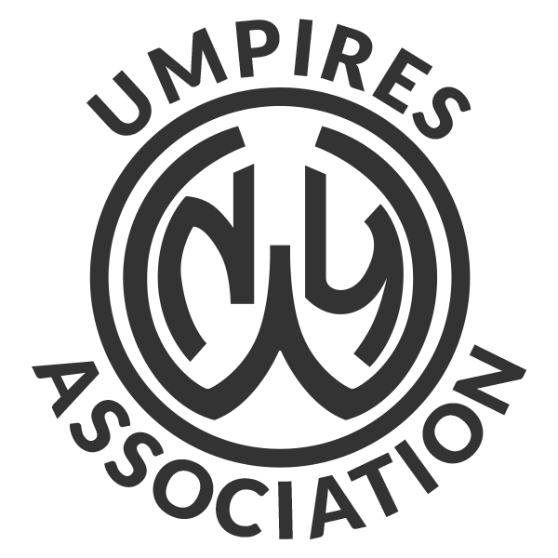 | Western New York Umpires Association  New Candidates Classes

Combined Class
February 4th - 7:30 PM - Introduction and Orientation
February 6th - 7:30 PM - First Class – Combined

Baseball Classes
February 13th - 7:30 PM - Classroom Training
February 20th - 7:30 PM - Classroom Training
February 27th - 7:30 PM - Classroom Training
March 4th - 7:00 PM - **General Meeting and Interpretation
March 5th - 7:30 PM - Classroom Training
March 10th - 7:00 PM - **Classroom Clinic 2 Man Mechanics
March 12th - 7:30 PM - Classroom Training
March 16th - 7:30 PM - **Final Exam

Softball Classes
February 10th - 7:30 PM - Classroom Training
February 11th - 7:30 PM - Classroom Training
February 18th - 7:30 PM - Classroom Training
February 24th - 7:30 PM - Classroom Training
March 2nd - 7:30 PM - Classroom Training
March 16th - 7:30 PM - **Final Exam
March 17th - 7:00 PM - **Classroom Clinic 2 Man Mechanics
March 18th - 7:00 PM - **Interpretation

In order to work High School Baseball &/or Softball Games, it is necessary to attend the meetings noted with a double asterisk **.

